Product Representation:
- Company Logo, with Banner
- Company Brief + Website Link option
- Product list + catalogue download option
- Product gallery/Images
Order to follow:
- Dissolution Accessories-Prosense
- Chromatographic Consumables
- HPLC & GC Vials
- Syringe filters, Membrane filters & Filter papers
- Chromatographic Columns
- GC & HPLC Syringes
- Other Chromatographic Accessories (D2 Lamps, Solvent waste kits, vacuum pumps, Manual/Electronic crimpers/decrimpers, vial storage boxes/racks & HPLC/GC-Column cabinets)
- Weighing Balance’s & it's accessories:
- Mettler Toledo
- Shimadzu
- Wensar
- Axis
- Precision Standard Weights
- Weighing boats & Glass Weighing Scoops

- Analytical Instruments:
- DLAB Scientific
- BEING Instruments
- DAN-LOGITECH
- Shimadzu- Spectroscopy
- Novasina-Water Activity meter
- Innova & Astello
- Mettler Toledo- Titrators
- Brookfield
- ANM industries
- Bandelin & Kubota
- Jeiotech
- Labman Instruments
- Hitachi & Jinan winner
- Ion Exchange & Adrona

- Buffers/chemicals/standards/glassware cleaning solutions

- pH & Conductivity Buffer Solutions
- Chemicals/Reagents/Standards
- Glassware Cleaning Solutions

- Bottle top-dispensers & Micro-pipettes

- Glassware & Plasticware

- pH/TDS/Conductivity meters

- Safety PPE’s & Lab essentials

- Quartz cuvettes & certified calibration standards

- Gas generators

- Refurbished instruments & Spare parts

Analytical Instruments:

- DLAB Scientific:
DLAB Scientific has been a leading supplier of high quality laboratory equipment.
Product List:
Liquid Handling:  - Mechanical Pipettes  - Electronic Pipette  - Pipette Fillers  - Pipette Controllers & Pumps Stepper  - Electronic Titrator  - Electronic Bottle-Top Dispenser  - Bottle-Top Dispensers  - Vacuum Aspiration System  Stirring & Heating:  - Overhead Stirrer Series  - Magnetic Hotplate Stirrers  - Hotplates  - Magnetic Stirrers  - Homogenizers  - Overhead Stirrer  Distilling:  - Rotary Evaporator  - Vacuum Controller | Mixing:  - Mixer  - Shaker  - Vortex Mixers  - Cell Disruptor  - Microplate Mixers  - Rotators  - Rocking Rotators  - Tube Rollers  - Shakers  - Spectrophotometers  Centrifuges:  - Palm Micro Centrifuges  - High Speed Micro-Centrifuges  - Low-speed Centrifuges  - Multi-Purpose Low-speed Centrifuges  Thermal Control:  - Dry Bath  - Thermo Mix  - Laboratory Water Bath  - Thermal Cyclers  - GelSMART
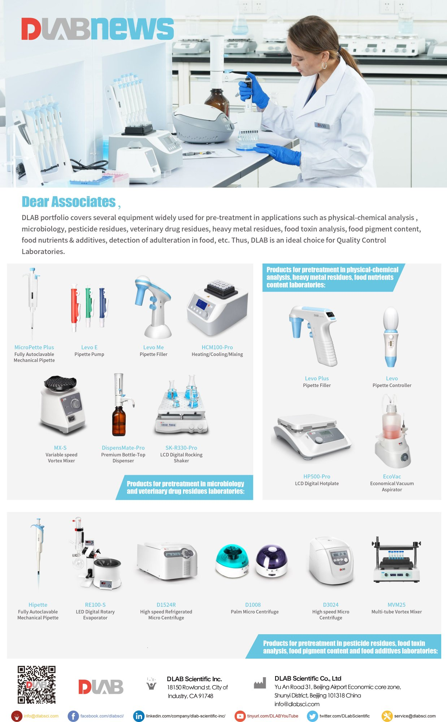

- Dan-Logitech:
The European Analytical Instruments Company.
Dan Logitech is a Laboratory Instrument company from the house of Glassco group. Focused to develop and provide customized and the most cost-effective and time bound solutions.
Glassco is one of the leading manufacturing companies in the field of scientific glassware from India, having a presence in over 83 countries across the World.
Dan Logitech is committed to provide Innovative, Customized and Adaptive equipment with Danish Design and Indian Engineering to be applied in various laboratories, universities, research centres and companies involved in scientific research from small to very large enterprises. With all its products with ISO and UL certification Dan Logitech has an excellent position in the international market.
Banner:
https://www.google.com/url?sa=i&url=https%3A%2F%2Fwww.glasscolabs.com%2Flaboratory-glassware-manufacturers-at-affordable-price%2F&psig=AOvVaw3CMxiqQn1Cn1I1QZHN6Jli&ust=1681547342343000&source=images&cd=vfe&ved=0CBEQjRxqFwoTCIComJH6qP4CFQAAAAAdAAAAABAK


Below images under gallery:
https://danlogitech.com/
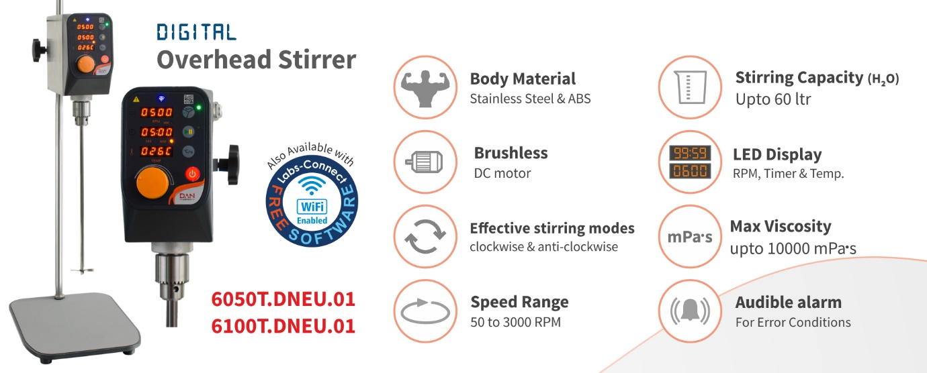

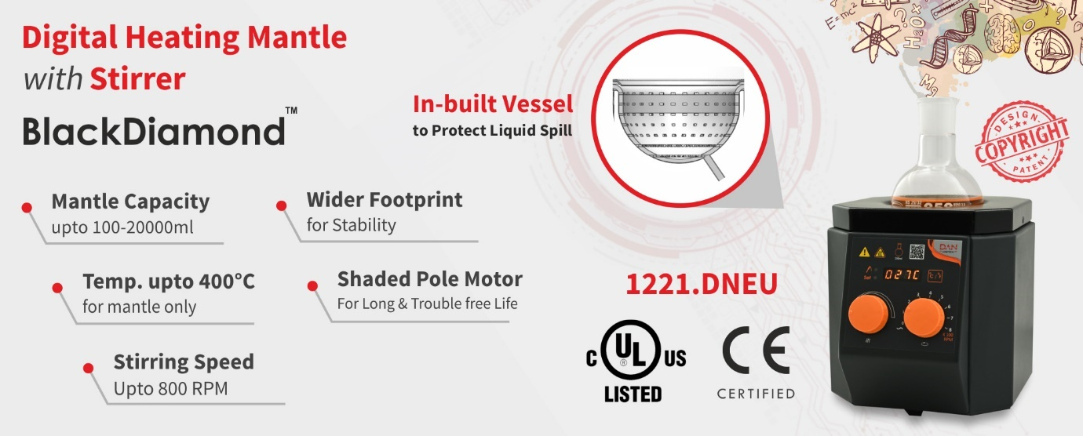
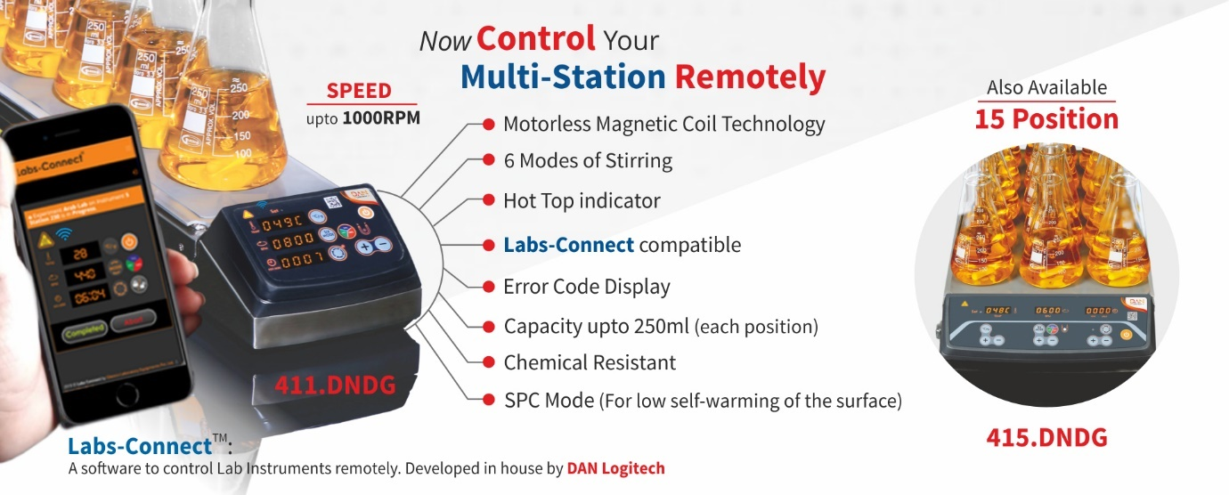
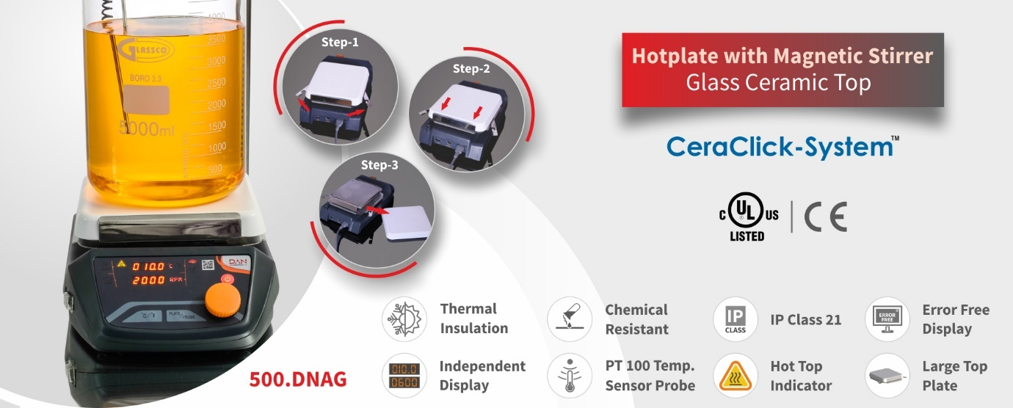
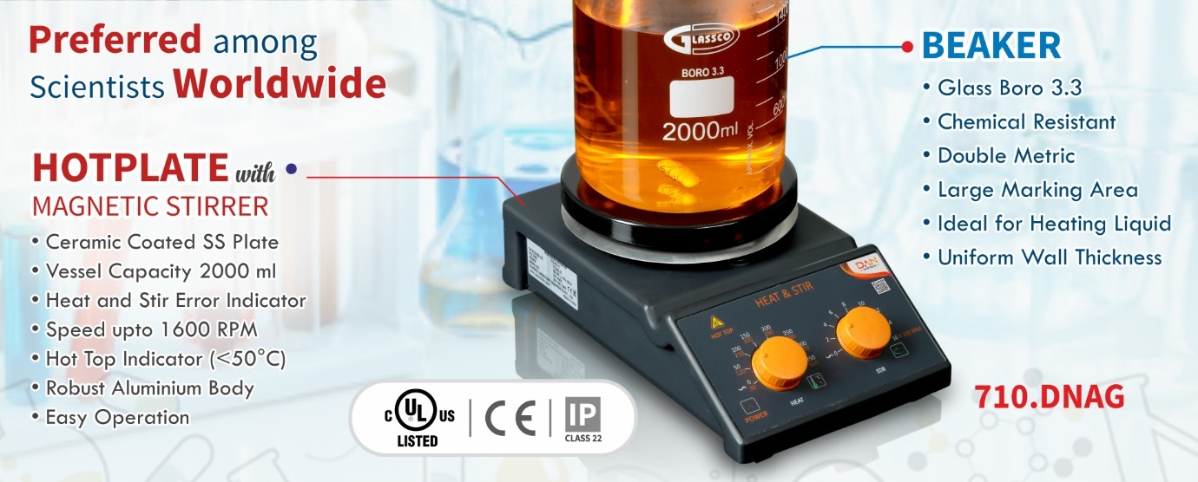-0pojpiij
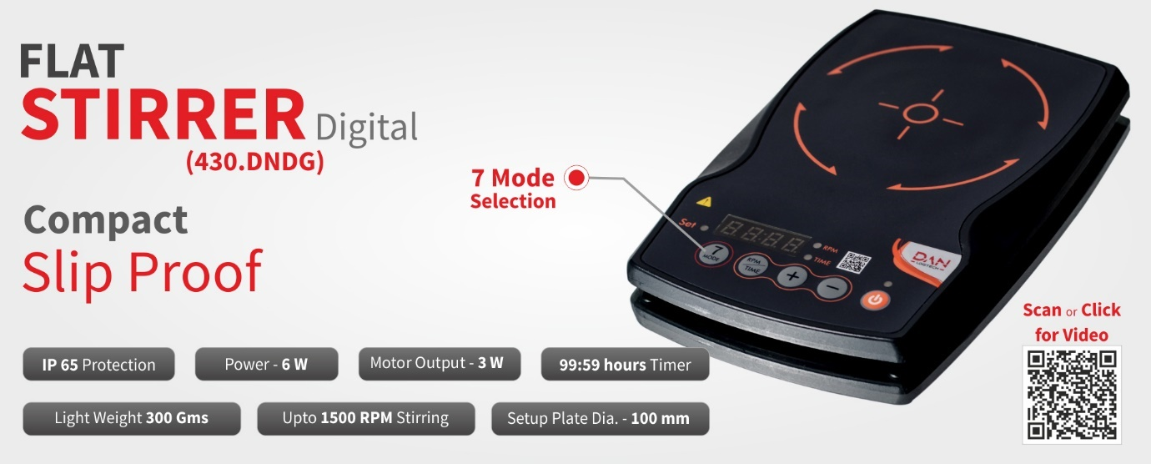
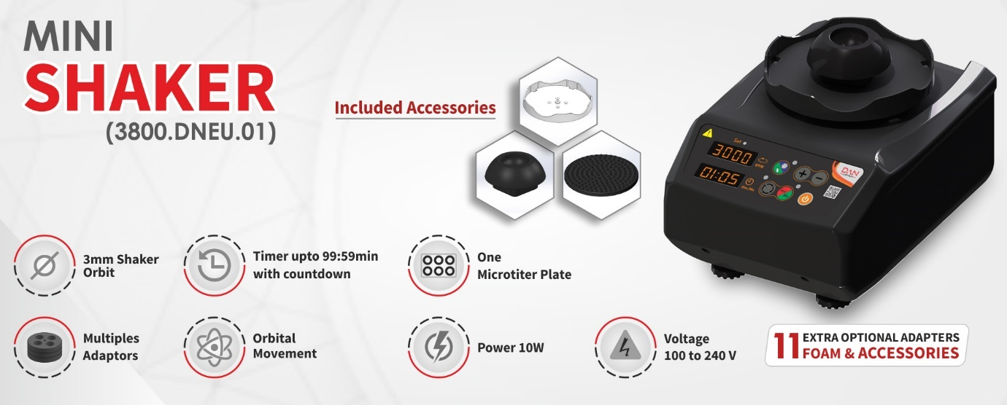

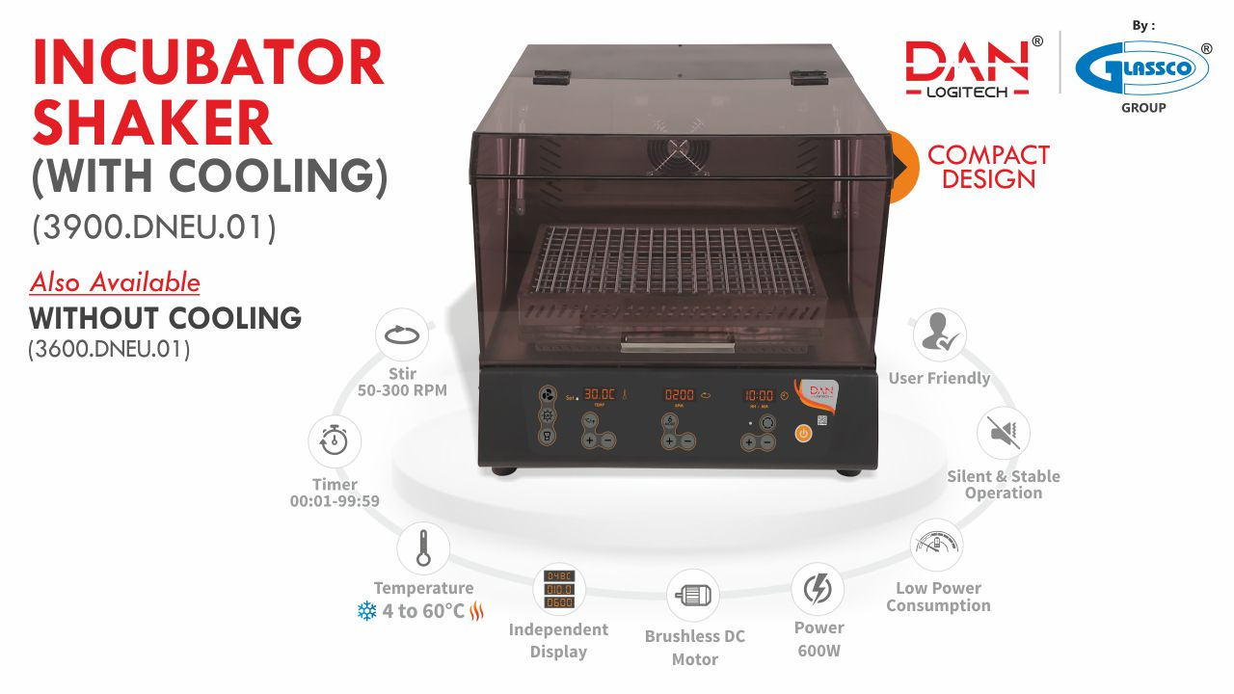
https://www.google.com/url?sa=i&url=https%3A%2F%2Fincubator-shaker.com%2F&psig=AOvVaw3CMxiqQn1Cn1I1QZHN6Jli&ust=1681547342343000&source=images&cd=vfe&ved=0CBEQjRxqFwoTCIComJH6qP4CFQAAAAAdAAAAABAE

- Brookfield Viscometers:

Brookfield has been the world standard in viscosity measurement for over 85 years. The expanding portfolio includes texture, moisture, toxic gas and powder analysis instruments for accurate material characterization measurements, making Brookfield instruments ideal for applications in many industries. It’s having centre of Excellence located in the US, Germany, China and India and a network of qualified training representatives and dealers. No wonder research labs, QC and production environments count on Brookfield's reliable instrumentation for dependability and accuracy.

Banner:

https://www.google.com/imgres?imgurl=https://www.labunlimited.com/images/viscometer-banner.png&imgrefurl=https://www.labunlimited.com/688/Viscometer&tbnid=YqW9Hxz2DS7PYM&vet=1&docid=IcZ93b1vOQvZfM&w=788&h=197&itg=1&hl=en-US&source=sh/x/im#imgrc=6FBMC-UCPU59FM&imgdii=wmClQl2fAp05IM

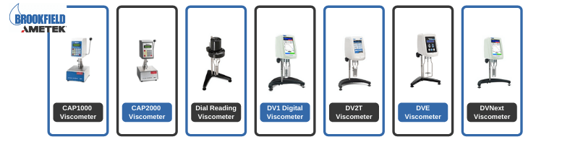

https://www.brookfieldengineering.com/products/viscometers

- Hitachi Instruments:
Hitachi High-Tech Corporation provide the statement-of-the-art technologies and service for you as a specialist of analytical instruments. Hitachi is committed to delivering world-class scientific instruments to augment the research and development sector in India. Our extensive range of scientific instruments includes Liquid Chromatographs, Electron Microscopes, Mercury Analysers, Potentiometric Titrators, Thermal Analysis Instruments, and Electron Microscopes. Through constant innovation and years of technical knowledge, we aspire to create products that bear the potential of transforming pivotal sectors like, agriculture, science, and education, etc.

Banner:
https://www.hitachifusion.com/human-fusion/about-hitachi-group/



- Bandelin



With our high-performance ultrasonic devices, you can achieve intensive parts cleaning without mechanically stressing the parts to be cleaned. For the respective application, we offer biodegradable cleaning and disinfection preparations which remove the contamination from the parts to be cleaned highly effectively. Compared to other cleaning methods, ultrasonic cleaning is therefore time- and cost-saving and at the same time particularly environmentally friendly.
Our expert advisors from the fields of industry, medicine and laboratory will be happy to advise you on your specific application and provide you with an offer for a suitable ultrasonic cleaner as well as suitable accessories such as baskets, holding devices and cleaning preparations.
Banner images:
https://bandelin.com/en/products/ultrasonic-baths/

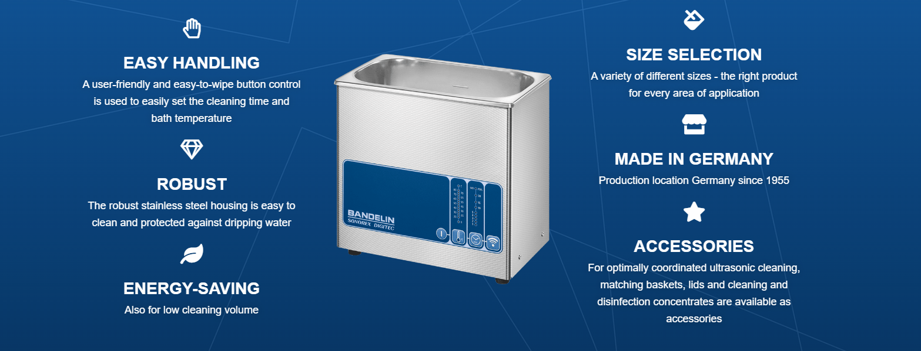

- Kubota:
KUBOTA is a leading laboratory centrifuge manufacturing company in Japan. Based on its long history and close relationship with its customers, KUBOTA has the deepest level of understanding of the centrifuge market not only in Japan but world-wide. Using its advanced technologies and expertise, Kubota has provided customers with new products and innovative functions such as automatic rotor identification function. As this case shows, KUBOTA continues to provide the highest degree of satisfaction for its customers.
Banner:
https://www.google.com/url?sa=i&url=https%3A%2F%2Fwww.centrifuge.jp%2Fnews-release%2F&psig=AOvVaw1olHPjUR4V4OlFqjnCLOAu&ust=1676990624127000&source=images&cd=vfe&ved=0CBAQjRxqFwoTCPCfkYarpP0CFQAAAAAdAAAAABAw

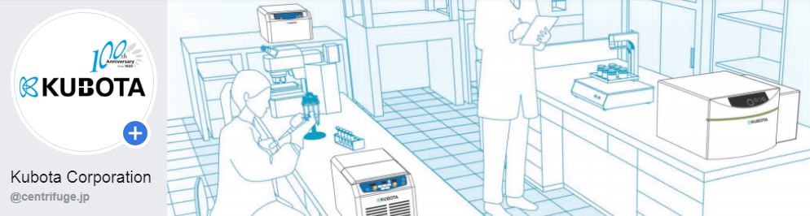

- Being:

SPOC is a reliable dealer to supply general equipment’s which are most used for more regular usage in laboratory like Ovens, Incubators, Chillers, Rotary Evaporators, Shakers and much more! from the market leader of Being Instruments.

Why Choose BEING Scientific Inc.

BEING has over 20 years’ experience engineering and manufacturing innovative and reliable laboratory equipment. Being Instrument, founded in 1997, is a high-tech enterprise mainly engaged in R&D, design, manufacture, sales and service of laboratory instruments and environmental test devices. Being has emerged as an industry leader as it remains committed to the “Technology-oriented quality assurance, service-based product improvement” principle.

The mission statement for BEING Scientific is to provide researchers and lab technicians across the globe with innovative and reliable options for Ovens, Incubators, Chillers, Rotary Evaporators, Shakers and much more! With over 20 years of experience in engineering and manufacturing, BEING will always try to provide new and better products to meet the everchanging needs of the laboratory. BEING conforms to ISO9001 quality standards, and our products are certified by CE, CSE, UL, and ETL.

With a commitment to both quality and value, BEING assures the buyer of laboratory equipment that will provide both performance and reliability.

Banner:

https://www.google.com/imgres?imgurl=https://hcs-lab.com/wp-content/uploads/2019/10/inner-banner-01.png&imgrefurl=https://hcs-lab.com/being-instrument/&tbnid=uq6b_uBA4JogiM&vet=1&docid=agA9t2UBia-6GM&w=5000&h=1667&itg=1&hl=en-US&source=sh/x/im

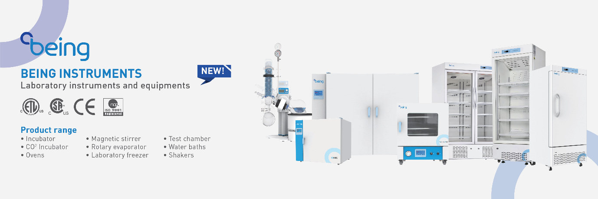

Product list:

LAB EQUIPMENTS:
- Laboratory Oven
- Laboratory Incubator
- Laboratory Magnetic Stirrer
- Laboratory Shaker
- Laboratory Muffle Furnace
- Laboratory Water Bath
- Homogenizer

ROTARY EVOPORATOR PACKAGE:
- Lab Rotary Evaporator
- Cooling Recirculating Chiller
- Cooling/Heating Recirculating Chiller
- Diaphragm Vacuum Pump
- Cold Trap
- Vacuum Controller

LIFE SCIENCES PRODUCTS:
- Ultra Low Temperature Freezer
- Low Temperature Freezer
- Biosafety Cabinet
- Clean Bench

NOTE: https://www.beinginternational.com/laboratory-instrument/
Take product images from above link.

- Jeiotech

JEIO TECH is pleased to introduce a new line of laboratory and environmental testing equipment. Our reliable instruments will assist you in your research endeavor in the field of biology, chemistry, medicine, pharmacology, and so forth. We are driven by innovation and our extensive product lines are at the cutting-edge globally in both scientific and industrial research instrument markets. In short, our top priority is to provide the world’s best products and services through outstanding quality and customer satisfaction at affordable prices.

Banner:

https://www.google.com/search?q=jeiotech+products+images+hd&tbm=isch&chips=q:jeiotech+products+images+hd,online_chips:laboratory:f6tdRrNqz1o%3D&rlz=1C1CHBF_enIN824IN824&hl=en&sa=X&ved=2ahUKEwivu4z0h7b9AhWR-HMBHX3GD6IQ4lYoBHoECAEQLQ&biw=1519&bih=647#imgrc=uwwxJpFMxb3f2M&imgdii=T68zQWNl4ED-yM

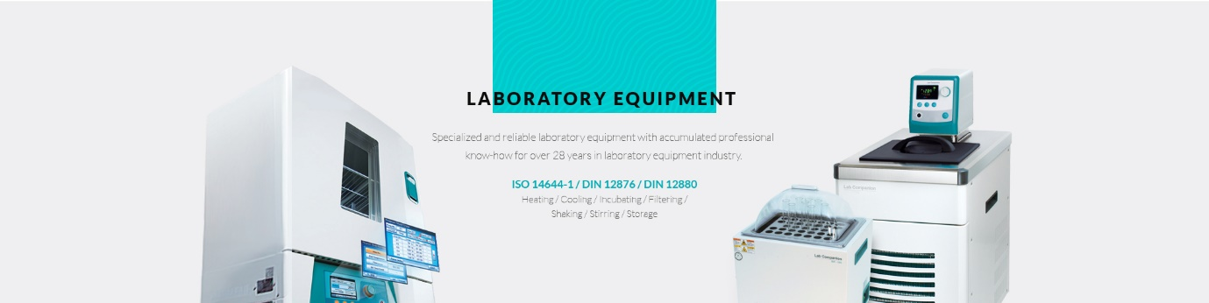

- Innova instruments:

Innova Bio-Meditech is one of the professional global providers of laboratory and medical devices. Firmly committed to our mission of “sharing innovative bio-meditech solutions with the world”.

Banner:
https://www.google.com/url?sa=i&url=https%3A%2F%2Finnovabiomed.en.alibaba.com%2F&psig=AOvVaw3eWolJ8LNf6ERFnbcQWAzy&ust=1681556133941000&source=images&cd=vfe&ved=0CBEQjRxqFwoTCPjyo_Gaqf4CFQAAAAAdAAAAABAE

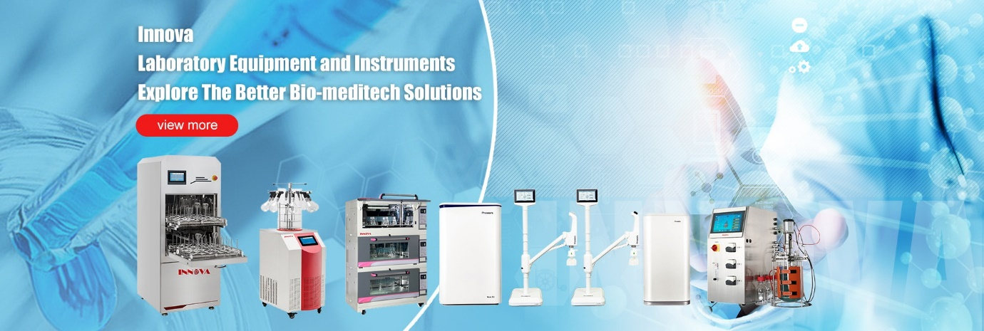
Products:
- Ice maker & Ice flaker
- Glassware Washer
- Freeze Dryer/Lyophilizer

- Vacuum Pumps:

Vacuum pumps are devices used to remove air and other gas molecules from a sealed volume creating a partial vacuum. Vacuum pump works on the principle of reducing the air pressure to low levels; this removes the gas molecules and other particle from the container creating a vacuum condition. The vacuum pumps come in different categories such as oil-free and the ones which use oil. The latest oil-free version is environment-friendly reducing the burden of pollution. A vacuum pump comes with specialised parts one of them to mention is the piston free vacuum pump, this enhances the efficiency of the pump. The vacuum pumps in the category are quite compact thus reducing the overall space requirement which can be otherwise used for placing other equipment. With efficient flow rate the vacuum pumps provide speedy processing of samples. With unique and excellent designs, the vacuum pumps are also economical, durable and leakage free. There is a mechanism to ensure unhindered flow and gas exchange. The pumps are made using materials which can easily be cleaned are non-corrosive in nature. The vacuum pumps can be used for a wide variety of applications such as for filtration of samples & compounds, purification, vacuum extractions, drying using a vacuum, measuring the suspended solids etc. Thus a wide variety of applications in combination with indispensable features of vacuum pumps gives them uniqueness.

SPOC can help in sourcing the best vacuum pumps at effective prices.

- Bottle Top Dispensers:

Bottle Top Dispensers are used to dispense aliquots of liquid from large containers. Such dispensers must be capable of reproducible dispensing, without wasting any reagent. Multiple adapters to accommodate a wide range of bottles is an added advantage. Some of the notable features of bottle dispensers include, they dispense most lab reagents including high purity acids and solvents, deliver accurate, precise volumes, increase laboratory safety and resist wear and damage. Diverse factors need to be considered while choosing a suitable bottle top dispenser. They include, volume to be dispensed, nature of liquids to be dispensed and choosing one from manual and digital units. Strong acids and bases, saline solutions, organic solvents, trace metal free liquids, sterile media, etc are some examples of liquids which generally need to be dispensed. Some of them may even have a Re-Circulation Valve which prevents the loss of reagents during purging by re-directing them into the mounted bottle and facilitates bubble free dispensing.
High-quality bottle top dispensers combined with routine calibration of equipment yield higher quality results and sometimes even cut down on reagent loss, the need for repeated experiments due to error, and precious man-hours spent in the lab in the long run.

DLab Scientific and Glassco are some of the leading suppliers offering a wide range of bottle top dispensers by SPOC.

- PH & Conductivity Meter:

pH meters are instruments used to measure the pH or the hydrogen-ion activity in water-based solutions. They measure the difference in electrical potential between a pH electrode and a reference electrode, hence indicating the acidity or alkalinity of a solution. Hence these are also called potentiometric pH meters, as they measure the voltage between the two electrodes and display the result converted into the corresponding pH value. Conductivity meters are used to measure the salt concentration, conductivity of a solution.

These devices contain a pair of electrodes and a simple electronic amplifier. The electrodes also referred to probes, are submerged into the test solution to determine the pH/conductivity. The glass electrode contains a glass bulb which is specifically designed to be selective to hydrogen-ion concentration. Hydrogen ions in the solution exchange for other positively charged ions present on the glass bulb, which creates an electrochemical potential across the bulb. The electrochemical potential developed between the two bulbs is detected by the electronic amplifier, which produces a readable output.

pH meter, conductivity meter, as well as in combination, is available in SPOC from world popular market leaders like Mettler Toledo' and Eutech brands.

- Titration Equipments:

Titration is a laboratory method of qualitative chemical analysis which determines the unknown concentration of a compound termed as the analyte. It is also known as volumetric analysis since volume measurements are significant in this procedure.
There are several different types of titrations, based on the type of reaction carried out per researcher requirement. The most common are acid-based and redox titrations, however, there also exist, gas-phase titrations, complexometric titrations, zeta potential titrations, and some forms of biological assays.

Titration experiments require a number of spare apparatus and manual physical effort from researchers. Automated titrators are designed to perform titrations in a specific and efficient manner.



- Pro-scientific
PRO Scientific Inc. is a global leader in the manufacturing of high quality homogenizing, mixing, shaking and stirring equipment.

